Turnitin.com Enrollment & Submission Instructions

- Go to turnitin.com and click on “Create Account.”

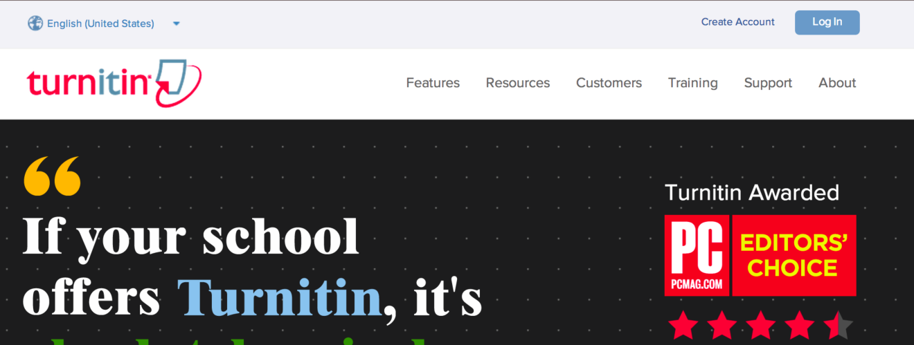

- Click on “Student” under Create a New Account.

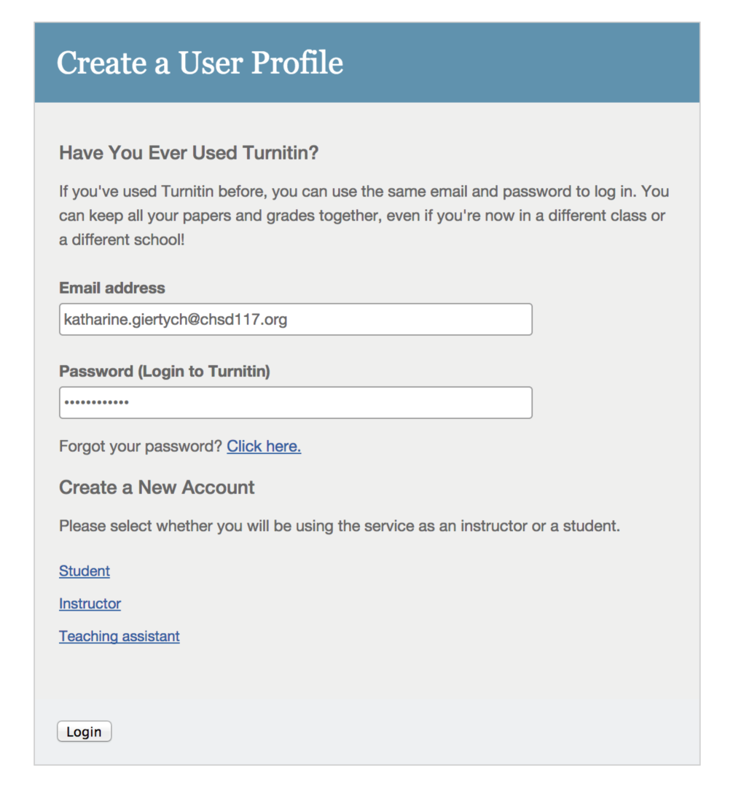

- Form: Create a New Student Account
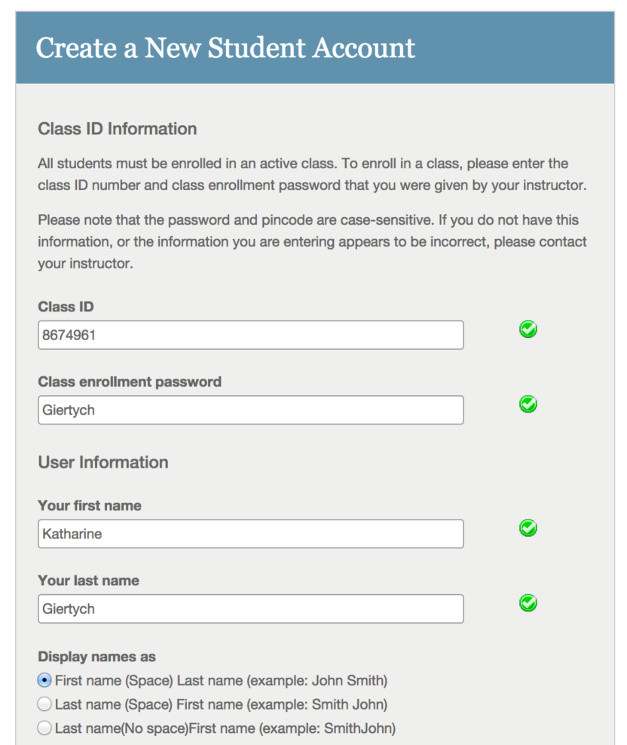
Password for everyone: Giertych
3rd Hour: 8674817
5th Hour: 8674961

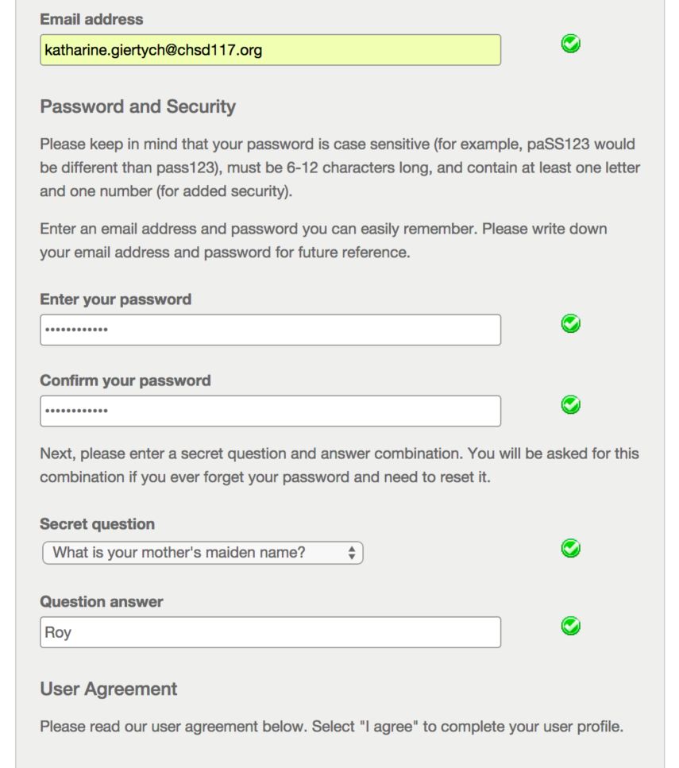
WRITE DOWN your password in your assignment notebook. I can’t look this up for you.
Use your school (CHSD117) email.

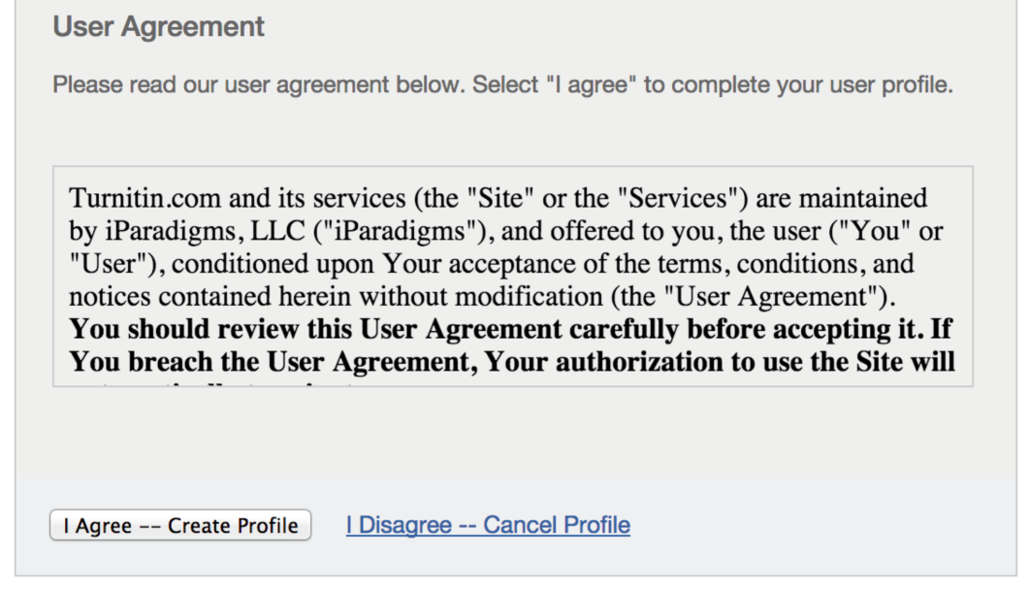

- The first screen you see when you log in will look like this. Click on the class for which you need to submit a paper.

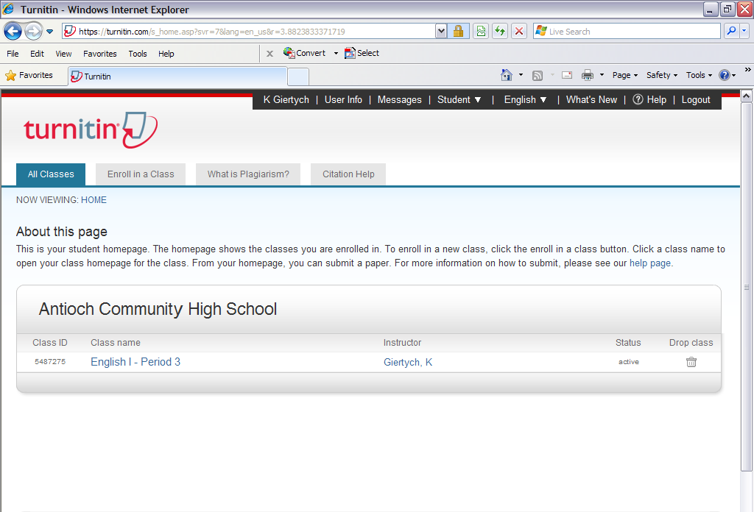

- When you click on the class name, the next screen will display all assignments you can submit to; choose the submit button associated with the assignment you are completing.

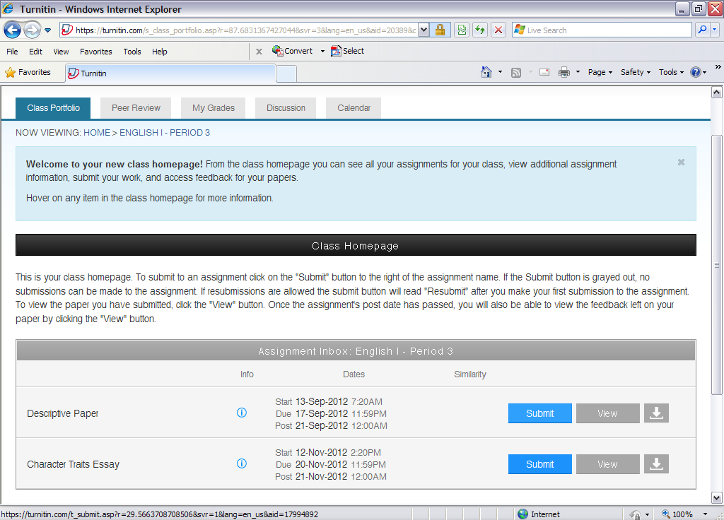

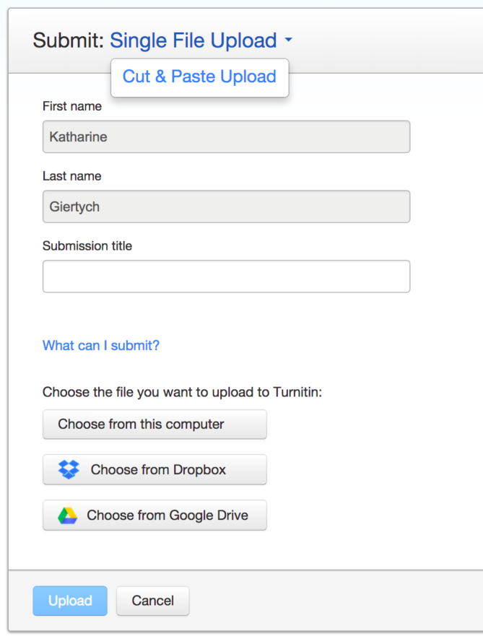
- When you click submit, you will then be prompted to either copy & paste or upload your essay. If you are uploading your essay, click browse and select the Word Document file containing your essay (just like if you were attaching a file to an email). Enter a title for your paper, and click “upload.”

…or you can just copy & paste the text of your paper.

You can upload the paper directly from your Google Drive…

- You will be brought to one final screen in which you are able to review your essay before submitting it. Check to make sure you selected the correct file, and click “submit.”

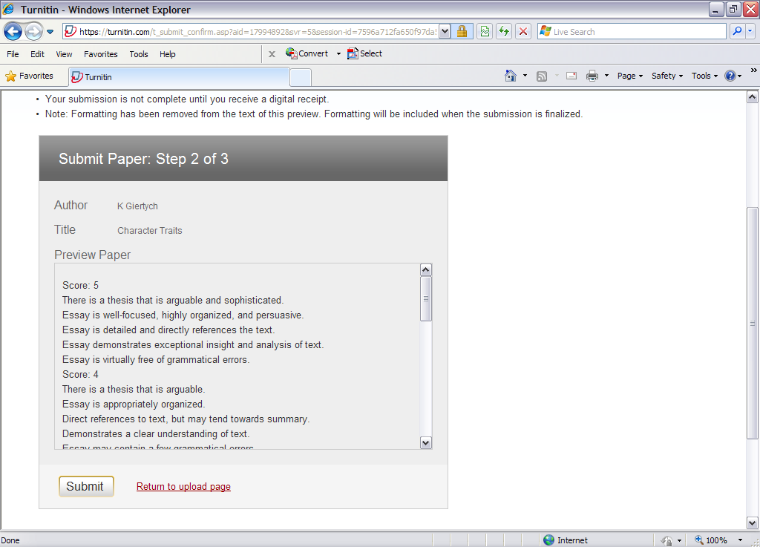

- If your upload is successful, you will then be brought to a digital receipt. You will also have a digital receipt emailed to you. If you do NOT see this screen and you have NOT received a confirmation email, then you have NOT actually submitted your essay! If this is the case, go to the home screen and try again.

