Modes of Persuasion
Ethos, Pathos and Logos are modes of persuasion used to convince audiences. They are also referred to as the three artistic proofs (Aristotle coined the terms), and are all represented by Greek words.

ETHOS

The Triangle of Persuasion

PATHOS
LOGOS

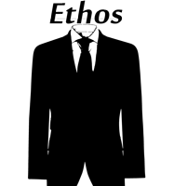
Ethos, or the ethical appeal of the author, means to convince an audience of the author’s credibility or character.

Ethos is the way in which the author presents the argument. Ethos can be developed by choosing language that is appropriate for the audience and topic (also means choosing proper level of vocabulary), making yourself sound fair or unbiased, introducing your expertise or pedigree, and by using correct grammar and syntax.
An author would use ethos to show to his audience that he is a credible source and is worth listening to.
Notes/Examples:

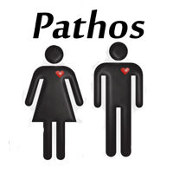
Pathos, or the emotional appeal, means to persuade an audience by appealing to their emotions.
Authors use pathos to invoke sympathy from an audience and to make the audience feel what the author wants them to feel. A common use of pathos would be to draw pity from an audience. Another use of pathos would be to inspire anger from an audience, perhaps in order to prompt action.
Pathos can be developed by using meaningful language, emotional tone, emotion evoking examples, stories of emotional events, and implied meanings.
Notes/Examples:

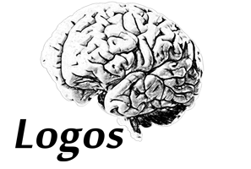
Logos, or the appeal to logic, means to convince an audience by use of logic or reason.
To use logos would be to cite facts and statistics, historical and literal analogies, and citing certain authorities on a subject.
Logos can be developed by using advanced, theoretical or abstract language, citing facts (very important), using historical and literal analogies, and by constructing logical arguments.
Notes/Examples:

