Comparing/Contrasting
Jim Stark and Holden Caulfield
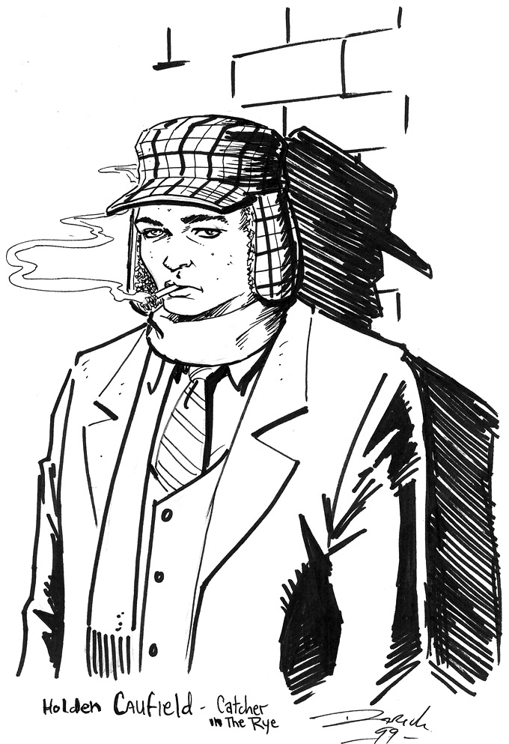
In both Rebel Without a Cause and J.D. Salinger’s The Catcher in the Rye, the alienated main characters both reject their society and secretly wish for a way to belong to it; in order to resolve this tension, Jim Stark and Holden Caulfield begin to explore ways that they can both resist and fit in, but on their own terms. Their experiments’ varying degrees of success can be measured by each character’s ability to compromise and to develop lasting friendships with others.

Part I: Rebel Without a Cause
 | Jim Stark | Holden Caulfield
relationships with parents and other adults

relationships with peers/friends and/or siblings

relationships with women/girls

ways of coping with trauma (including death)

ways of rebelling against society

Rebel or Whiny American?

Read the article titled “Holden Caulfield – American Whiner” by George F. Will and answer the following questions. Each response should be a thoughtful, detailed paragraph.

“…that exhausts Holden’s resemblance to anyone heroic.”

- Many Holden supporters have looked to him as a symbol for individuality. Should Holden be looked to as a hero to outcasts?

“He was feeling entitled to feel quite sorry for himself. His feelings fascinated him, and his creator, J.D. Salinger, thought readers should sympathize with them.” | vs. | “Holden was a new social type that subsequently has become familiar – the American as whiner.”

- Holden is classified as the original teenage rebel. Is this view valid, or is Holden just another whiny, entitled American?

