Online Writing Portfolio: How-To

Step 1: Log-in to your Google Drive.
Step 2: Click “Create” and select “Folder.”

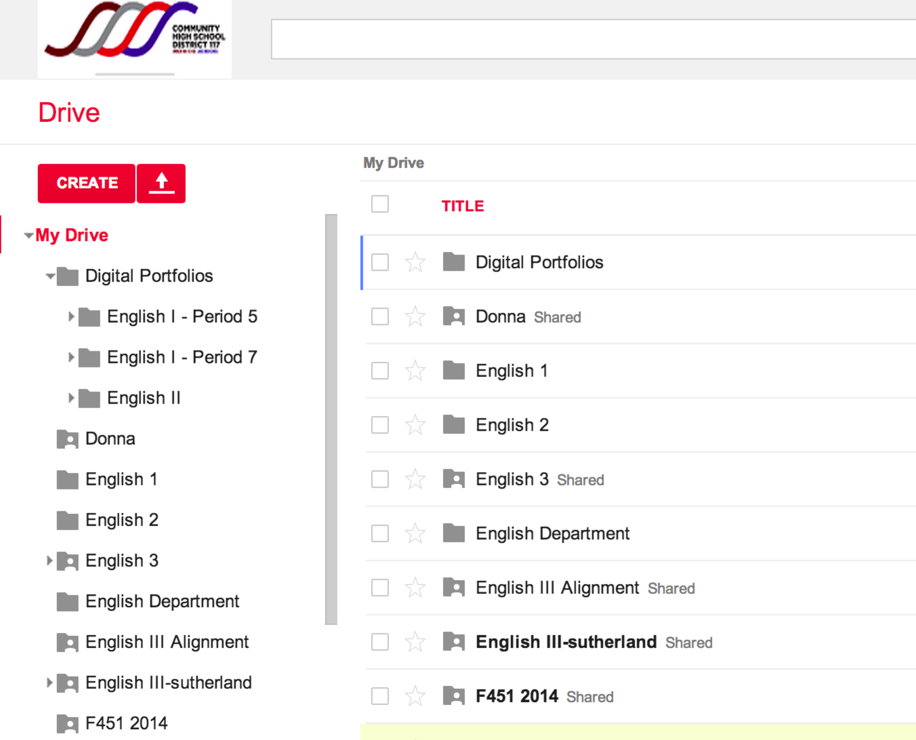

Step 3: Name your folder (Lastname, First Class).

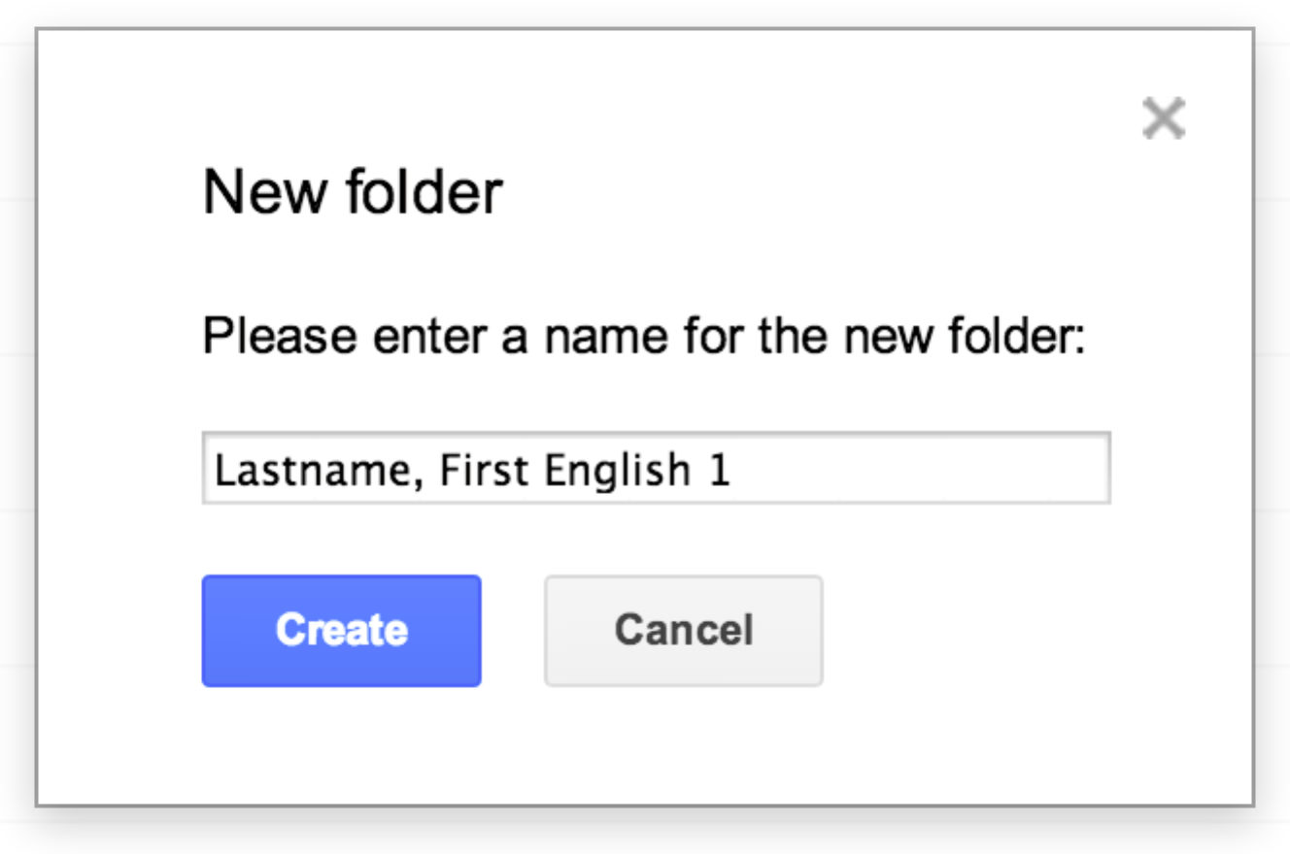

Step 4: Right-click on your newly created folder and select “Share.”

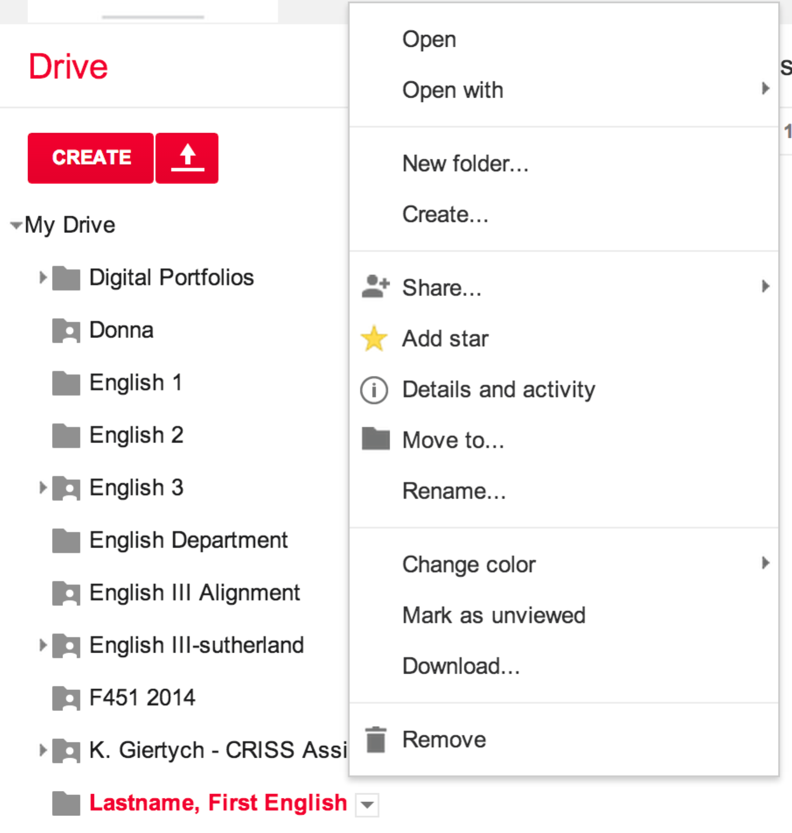

Step 5: Invite your teacher by typing in his or her school email.

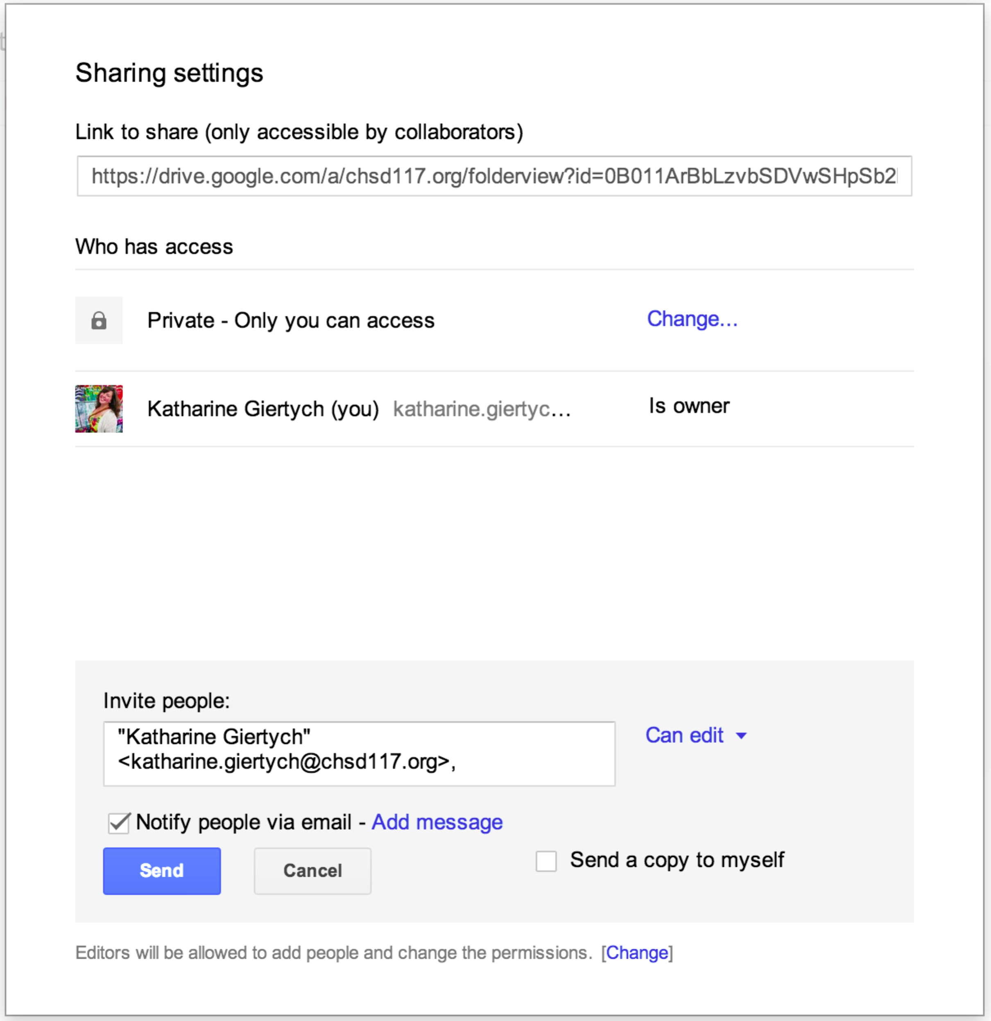
Leave this dropdown as “Can edit.”

