Analyzing Visual Rhetoric, Part 3: Political Cartoons
English III
Standards:
- RI 2b: Analyze and evaluate the effectiveness of the structure an author uses in his/her argument, including whether the structure makes points clear, convincing, and engaging.
- RI 2c: Determine an author’s point of view or purpose in a text in which the rhetoric is particularly effective, analyzing how style and content contribute to the power, persuasiveness or beauty of a text/image.
- RI 3a: Integrate and evaluate multiple sources of information presented in different media or formats.
Directions: Using the SCANS chart to sequence your notes, analyze this political cartoon.
Cagle, Daryl. Ferguson Wave. Political Cartoon. The Cagel Post. Cagel Cartoons. 21 Aug. 2014, Web. 25 Aug. 2014.
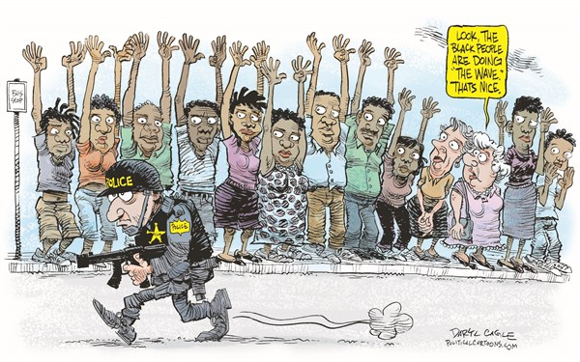

Subject
Contents
Attitudes
Narrative
Symbolism
Conclusions

Directions: Using the SCANS chart to sequence your notes, analyze this political cartoon.
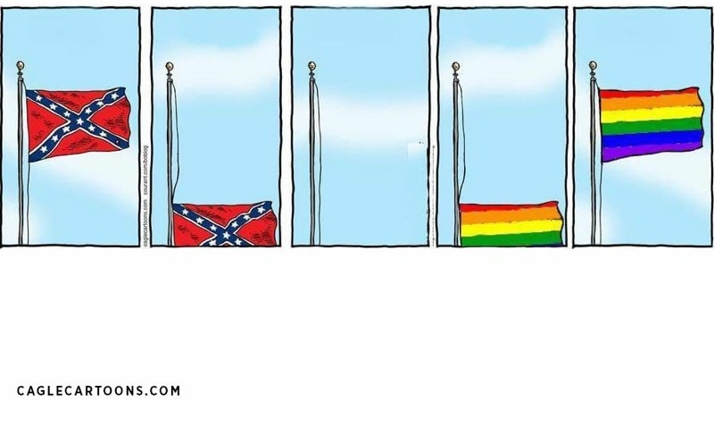

Subject
Contents
Attitudes
Narrative
Symbolism
Conclusions

