Analyzing Visual Rhetoric, Part 2
English III
Standards:
- RI 2b: Analyze and evaluate the effectiveness of the structure an author uses in his/her argument, including whether the structure makes points clear, convincing, and engaging.
- RI 2c: Determine an author’s point of view or purpose in a text in which the rhetoric is particularly effective, analyzing how style and content contribute to the power, persuasiveness or beauty of a text/image.
- RI 3a: Integrate and evaluate multiple sources of information presented in different media or formats.

Use the SCANS chart (below) to sequence your notes when analyzing a visual. Remember that the genre of the visual may determine which questions are relevant to your observation.
Desegregation in Tennessee
In its landmark 1954 decision, Brown v. Board of Education, the Supreme Court ruled that separate schools for black and white students were unconstitutional. Clinton High School in Tennessee was ordered by a federal judge to be the first to integrate. Photographer Robert W. Kelley, sent by Life to document the first day, encountered this scene in front of the school.
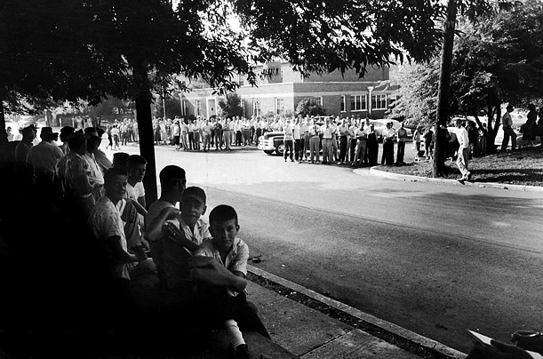
Image link (photo #2): http://www.time.com/time/photogallery/0,29307,1704734_1520199,00.html

SCANS chart based on material from Eva Arce, Barbara Murphy, Frames of Mind (DiYanni and Hoy), and It’s No Laughing Matter – Analyzing Political Cartoons (http://memory.loc.gov/learn/features/political_cartoon/index.html)
Subject | Identify the subject of the visual: determine as much as possible from the information provided what the context, date, and subject matter are.
Contents | Identify:  - major components, such as characters, visual details, colors, symbols  - verbal clues, such as titles, tag lines, date, author, dialogue  - the positions/actions of any characters, especially relative to one another or to their surroundings  - traits of the characters or objects  - significant images, including repeated or patterned imagery  - composition lines (parallel, crossing)
Attitudes | - Notice position and size of details: exaggerations, focal points, or emphases of other kinds  - Notice details that create positive or negative reactions to characters or objects portrayed in the visual  - Does the author indicate alternative viewpoints?  - Does the place and environment create a mood (ex: spooky, eerie, nostalgic, etc.) for the audience?  - What are the reactions of other “characters” to the “central character(s)”?  - Is there any irony in the way characters or situations are portrayed? How do you know it’s ironic?
Narrative | - Does there appear to be any conflict? What are the attitudes of the characters to the conflict? How does that conflict seem to be progressing?  - Does something refer to an event or person in literature or history? What do you know about this literary or historical person or situation?  - What do the actions of the characters or their relative positions say about them and their relationships?
Symbolism | - Do some of the concrete items represent abstract ideas?  - What colors are used and what do these colors symbolize?  - Are there contrasts of lightness and darkness, of color, of shape, of size?  - How do composition lines break up or align parts of the image?
Conclusions | - Based on the various details, what can you say is the artist’s purpose in creating this piece?  - Purpose is like the artist’s thesis statement—what is he/she trying to prove to his/her audience?  - What is the artist’s attitude or feeling about the subject portrayed in the image?

Your Notes:
Subject
Contents
Attitudes
Narrative
Symbolism
Conclusions

