Analyzing Visual Rhetoric
English III
Standards:
- RI 2b: Analyze and evaluate the effectiveness of the structure an author uses in his/her argument, including whether the structure makes points clear, convincing, and engaging.
- RI 2c: Determine an author’s point of view or purpose in a text in which the rhetoric is particularly effective, analyzing how style and content contribute to the power, persuasiveness or beauty of a text/image.
- RI 3a: Integrate and evaluate multiple sources of information presented in different media or formats.

Visual Rhetoric: Background
If rhetoric is the art of communicating effectively and persuasively, it stands to reason that communicating visually can be as much an exercise in rhetoric as communicating in writing.
When we examine visuals, we consider the strategies of the artist – the elements of visual composition – to determine what the purpose of the image is.
Visuals may come in a variety of forms:
- maps, charts and graphs
- political cartoons
- posters or advertisements
- paintings or photographs

(From Robert DiYanni and Pat C. Hoy, Frames of Mind. Thomson Wadsworth, 2005.)
Every genre has its own conventions. You should adapt your analysis to consider the usual ways of representing ideas visually within that genre.

For example:
- Photographs use composition lines, contrast, and color to establish relationships between people and objects.

- Political cartoons use exaggeration to emphasize traits of characters and symbolism to communicate concepts and situations in a compact way.

- Paintings use color and symbolism, and may often use allusion to tell a story about their subjects.

- Posters and advertisements use color and composition to attract attention, and symbolism and imagery to persuade.

- Graphs and charts select sets of data and present them in a manner that makes them easy to interpret, sometimes showing trends or contrasts.

Your task is to observe the details of the visual material, consider how they work with one another to create understanding in the audience, and determine the artist’s purpose in creating the visual piece.
Introductory Exercise: What do you see? Examine the photograph below closely before answering the questions that follow it. (Write on/around the image.

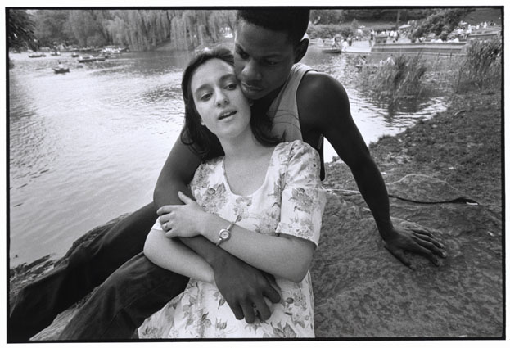
Bruce Davidson, “Young Interracial Couple”

- Divide the photograph into two parts, one on each side of the couple. List what you see to the right and then list what you see to the left. What do the lists suggest about what might be Davidson’s concerns and values? Explain.

- Start at the intersection of the two faces. Using a pencil or colored pen, follow the line along the curve of the girl’s face and extend the line up toward the top of the photograph. What do you notice with this extension? Look for other lines and movement. How do those lines break up the photograph? What do you see in the various sections created by those lines?

- Focus on the expression of each face. How would you describe each expression?

- What does the photograph suggest about the couple’s relationship? Explain.

- Reflection: How do your own opinions and values with regard to this image influence your understanding or interpretation of the image?

